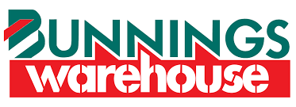

Tacoma Public School P & C has been lucky enough to secure 2 Bunnings BBQs as a fundraiser. All funds raised on the day from selling sausage sandwiches and drinks will go back to the school.
The first BBQ is at Lake Haven Bunnings on Saturday 1st September
The second BBQ is at Tuggerah Bunnings on Sunday 7th October
We will need volunteers to help cook and serve on the day. If you can help on either of the days or both please fill in the below slip and return to the office.
Our events coordinator will be in contact with you closer to the date to confirm your date and time.
We are only asking for your assistance for 2 hours, but if you can help for longer that would be fantastic.
More details will be provided in the newsletter and on our P&C Facebook Page when it gets closer.
We appreciate you providing your time on a weekend to help us raise funds for our school.

Tacoma Public School P & C – Bunnings BBQ Volunteer Form

Parent’s Name:_____________________________________ Phone: _________________________
Child’s Name: _____________________________________ Child’s Class: ____________________

I can help at Lake Haven Bunnings on Saturday 1st September (please circle if you can assist on this day)
Preferred time to help (please circle): Morning Lunch Afternoon

I can help at Tuggerah Bunnings on Sunday 7th October (please circle if you can assist on this day)
Preferred time to help (please circle): Morning Lunch Afternoon

